This project uses three main Python libraries: **Ultralytics**, **OpenCV**, and **Matplotlib**. The Ultralytics library provides the YOLOv8 model, which is a powerful and fast object detection model used to identify objects in images. OpenCV is used to load and process the image, making it ready for detection. Matplotlib is used to display the final image along with the detected objects highlighted. In simple terms, the code loads an image, uses YOLOv8 to detect objects like people or animals in it, and then shows the image with boxes drawn around those detected objects.

Image use in project

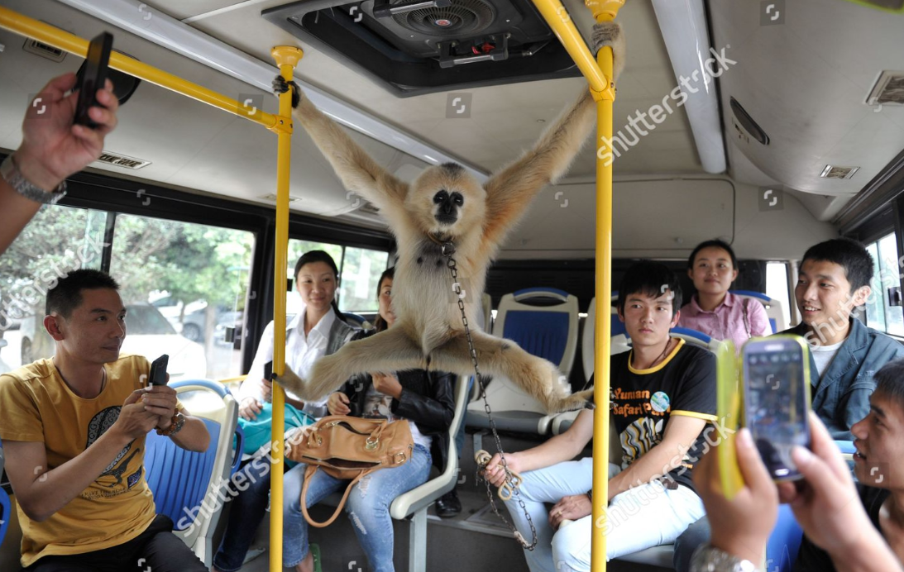

Other imgaes are auto generated